**Lab Task:**

**1.** Write a C Program that takes a number as input and searches that number in a predefined array.

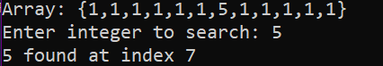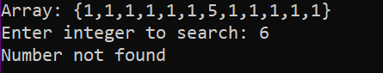

**2.** Write a C Program that takes 10 numbers as input in an array and shifts all the elements 1 unit to left.  


**3.** Write a C Program that takes 12 numbers as input and and sums up pair of each element and stores the result in another array of size 6



**4.** Write a C Program that takes 15 numbers as input in an array and prints the sum of its

elements.

Input: {1,2,3,4,5,6,7,8,9}

Output: 45

**5.** Write a C Program that takes 20 numbers as input in an array and prints them in reverse order.

Input: {1,2,3,4,5,6,7,8,9}

Output: 9 8 7 6 5 4 3 2 1

**6.**  Write a C Program to find the minimum and maximum number in an array of 30 integers.

Input: {4,1,6,8,10,21,8,9,2,6}

Output:

Minimum Number = 1

Maximum Number = 21